Park Schools Federation Policies - DINNER MONEY

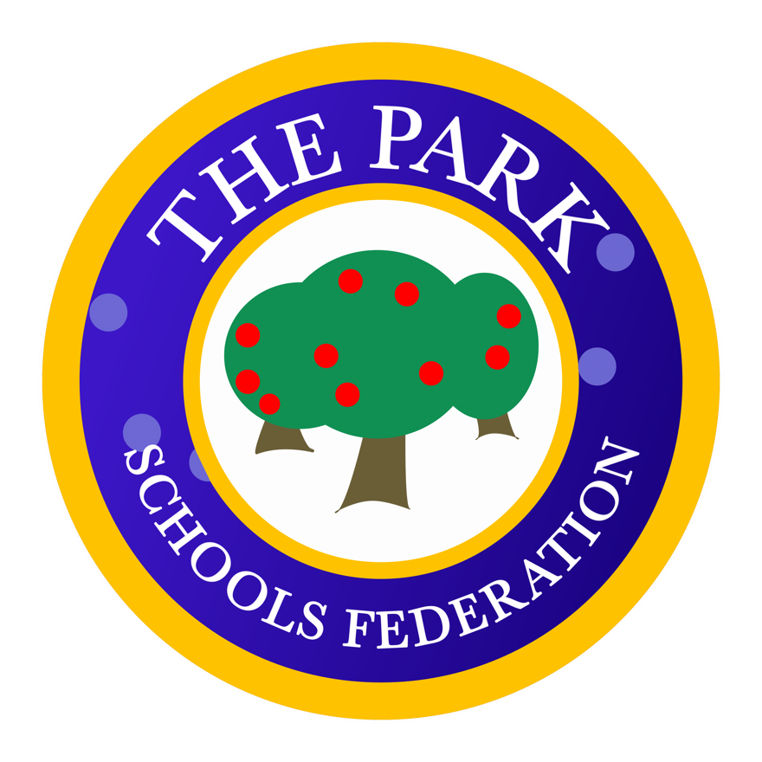
Record of Policy Amendment/History
Date Approved | Minute No.
25.03.14 | 25/14
27.01.15 | 7/15
14.07.15 | 72/15
06.12.16 | 151/16
04.10.18 | 70/18
21.10.21 | 49/10.21
20.10.22 | 99/10.22
12.10.23 | 148/10.23

Background
The Park Schools Federation Debt Policy has been adopted to ensure that a consistent and fair approach is followed to debt incurred by parents/carers whose children take school dinners. As the Local Education Authority is no longer accountable for the administration of dinner money debt the responsibility now falls on the school to pursue instances of non-payment. As a result, the school budget will have to directly fund any outstanding debts that cannot be recovered thereby directly affecting the amount of money that is available to provide education to all pupils.

Provision of School Meals

The Schools Meals Service is no different to any other business in that meals have to be paid for by someone. Free School Meals are available for parents who meet certain criteria including the receipt of state benefits. Anyone who may qualify for Free School Meals should contact the school office for further information. Free School Meals are a statutory right and it is important that all parents/carers who qualify take up their child’s entitlement so that they can receive a School meal each day.

Information on the entitlement to free school meals and an application form can be found on the Derbyshire County Council’s website:
https://www.derbyshire.gov.uk/education/schools/your-child-at-school/meals/school-meals/free-school-meals.aspx
If a child’s entitlement to free school meals expires or the parent/carer personal circumstances change the parent/carer must provide a packed lunch or send payment in advance for a school dinner.
Cost of School Meals
School meals are available to children at a cost of £3.25 per day or at no cost to those in receipt of Free School Meals entitlement. School meals must be paid for in advance. Any revision to the school meal prices will be notified to parents/carers the term prior to the new charge taking effect.
Payment for School Meals
Please send payment on a Monday morning via the Parent Pay app. Cash is still accepted at the school office (if in cheque format made payable to Derbyshire County Council) in a sealed envelope clearly marked with your child’s name, class name and amount enclosed. The School must ensure that all dinner money collected is banked in a timely manner in accordance with the School’s Financial Regulations which are periodically inspected by audit.

Management of School Meal Debts
To ensure that the School’s budget is not adversely affected by the cost of School meal debt the Governors consider the fairest system to all families is to pursue a ‘Zero Tolerance’ approach. Although, this may seem harsh to some parents it is important that the school budget is spent for the benefit of all our pupils and not a small number.

If a child arrives at school without a packed lunch or payment, or if a child’s entitlement to free school dinners has ceased, the School will telephone the parent/carer in the first instance to establish if alternative arrangements have been made.
When a child has failed to produce dinner money the school may allow a meal to be provided where it is felt that this is a temporary situation. e.g. Lost or forgotten dinner money, temporary hardship etc. however details should be recorded in writing and a record maintained and monitored.
If a child takes a school meal which has not been paid for, the school will contact the parents via the telephone in the first instance. If payment is then not made a letter detailing how much is owed will be sent to the parent/carer requesting payment directly to the school within 7 days. The same process will be used if a cheque is not honoured by the bank. Prompt action will be taken to address any debt issues at an early stage in order to prevent arrears amassing.
Where a child continues to require meals, the School must establish if the child is entitled to free school meals, or if the parent/carer is experiencing hardship which affects their ability to pay. Under these circumstances the parent/carer should be invited to apply for free school meals or speak confidentially to the School Resources Manager/Headteacher.
When the debt exceeds £16.25 for a child or family a telephone call will be made informing them to provide their child/children with a packed lunch the following day if the debt is not paid to prevent further arrears. If the child/children is/are not provided with the requested packed lunch and the parent/carer cannot be contacted, the School will provide a sandwich and a drink only and send a formal letter. (Example letter 1 separate document)
If the debt exceeds £48.75 for a family and/or action proves unsuccessful in securing dinner money arrears, the School should inform the local Safeguarding Team and formally write to the parent/carer, explaining that the School is not obliged to provide a school dinner where advance payment is not forthcoming or where authorisation for free school dinners has not been received (Example letter 2 seperaste document).

Monitoring and Recovery of School Meal Debts

At each meeting of the Governing Body the Head Teacher will provide Governors with details of any outstanding dinner money debt and the current position with regard to such debt. The aim of the School’s dinner money policy is to minimise the opportunity for debt balances to build up and incurring costly referral to the School’s solicitors. The School does however, reserve the right to begin legal proceedings to recover outstanding school meal debts and inform the local authority that a child is not being provided with a suitable meal at lunch time.

All Write-offs of outstanding debt must be approved by the Governing Body/Finance Committee following submission of details of the debt by the Head Teacher together with reasons for no further action being taken.

